RAMANUJAN COLLEGE

(University of Delhi)

computer network
Computer Network
(CISCO PACKET TRACER)

(PRACTICAL)
NAME:- RAVIKANT MAURYA
COURSE:- B.Sc.(HONS) COMPUTER SCIENCE
COLLEGE ROLL NO. :-20221433
EXAM ROLL NO. :-20220570026
YEAR:- Second year
SEMESTER:- THIRD
NAME-RAVIKANT MAURYA

Networking Practical
Q.1:- To study and perform PC to PC communication using Ethernet cable.
Steps:-
Step 1:- Open the Cisco Packet Tracer .
Step 2:- Click on End Devices that is on the left corner of Cisco Packet Tracer window.
Step 3:- Select two PCs as PC0 and PC1 and drag them to Logical Area.
Step 4:-Connect both the PCs with a Ethernet Cable (Copper Cross-Over) that is present in Connections.
Step 5:- Click on PC0 and select desktop and then click on IP Configuration .
Step 6:- Check the IP is static and enter the IP you wish to give whether IPv4 or IPv6(PC0=>IP-192.168.10.1) and close the window it automatically save it.
Step 7:- Similarly at PC1 ( PC1 => IP - 192.168.10.3 ).
Step 8:- To verify connection click on any PC and then again click on Desktop and then on Command Prompt and here enter the ping ‘Destination IP Address’.
Screenshot:-
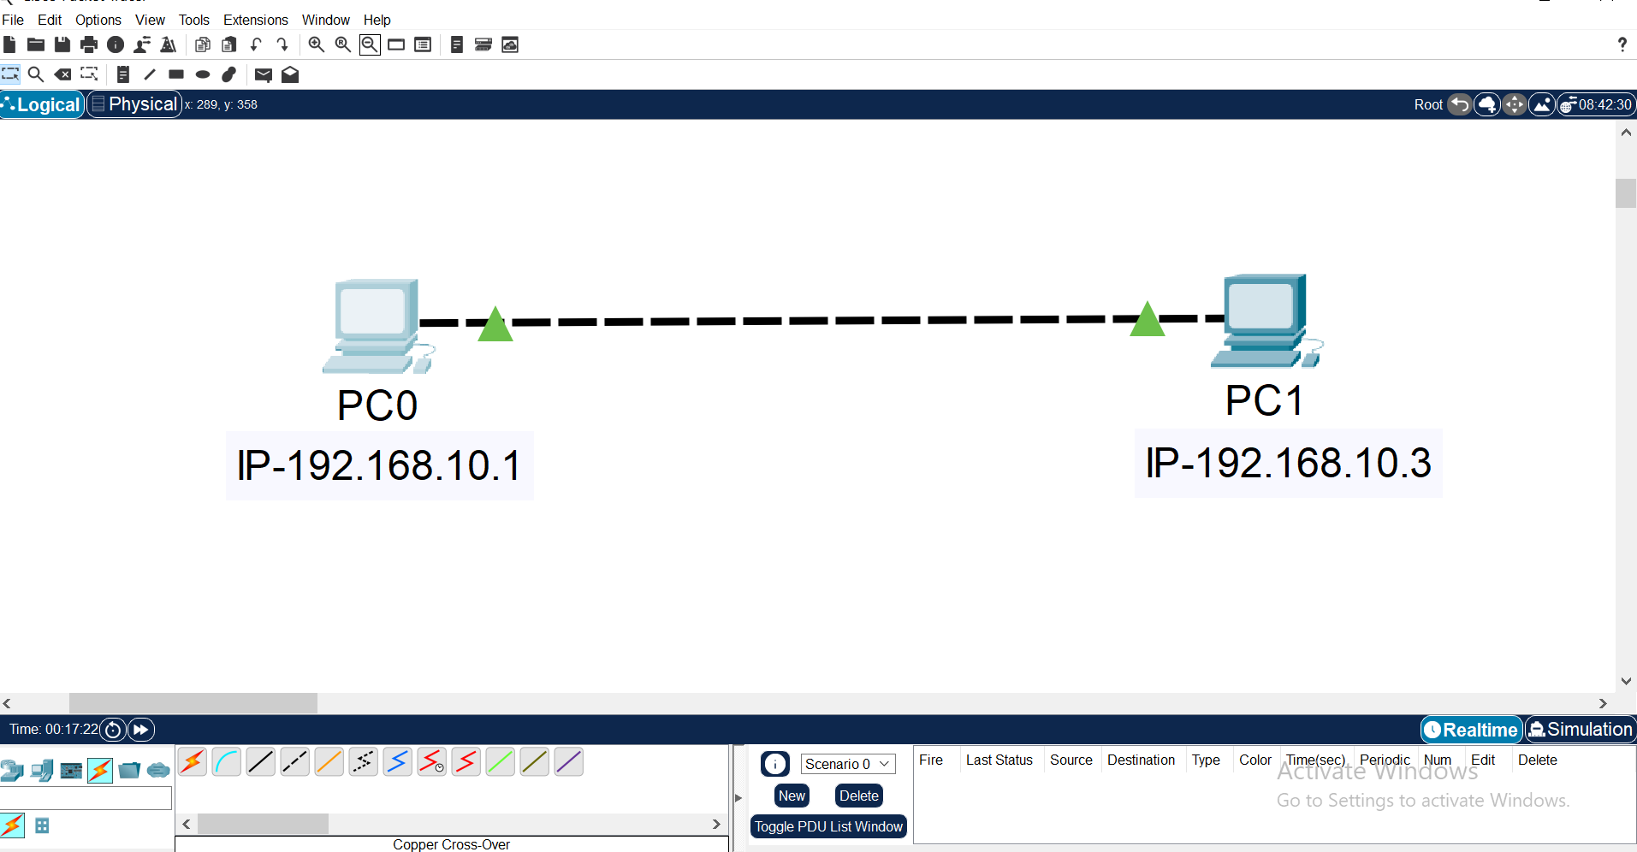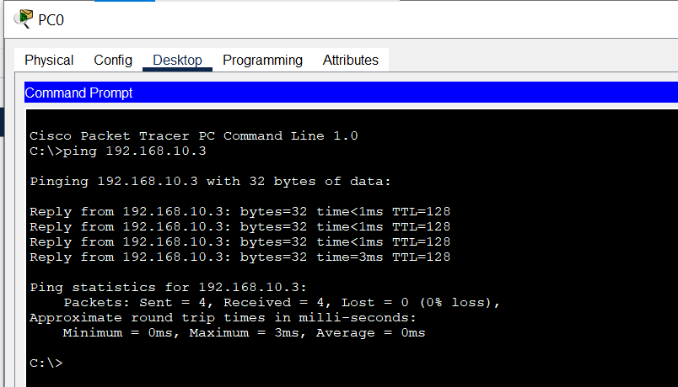

Q.2:- To create a Star Topology using hub and switch.
Steps:-
Step 1:- Open the Cisco Packet Tracer .
Step 2:- Click on End Devices that is on the left corner of Cisco Packet Tracer window.
Step 3:- Select 5 PCs according to your need as PC0,PC1,PC2,PC3 and PC4.
Step 4:-Click on Networking Devices , select and drag a hub or switch from there.
Step 5:-Connect all PCs to the hub/switch using a Copper Straight-Through wire.
Step 6:-Configure the IP Address of each PCs by clicking on each PC and selecting desktop and then click on IP Configuration and then enter the IP you wish to enter .(PC0=>192.168.10.6),(PC1=>192.168.10.2), (PC2=>192.168.10.3), (PC3=>192.168.10.4) and (PC4=>192.168.10.5).
Step 7:-Test each network using command prompt by clicking on pc and selecting desktop and then clicking on Command prompt.
Step 8:- Select a PDU and give to any two PC randomly.
Step 9:-HUB:
Click on Simulation on right corner of CPT window and see how packets are moving from one PC to another PC using HUB.(PC1 sends the message to Hub and hub send it to rest of PCs and only destination PC 3 will receive it and other PCs will discard it similarly when PC3 send the reply to hub and it send to all PCs and only PC1 will get it and other PCs will discard it .
SWITCH:
And also see how packets are moving from one PC to another PC using SWITCH.(PC2 sends the message to SWITCH and SWITCH send it to the only destination PC 3 will receive it and similarly when PC3 send the reply to switch and it send the reply only to PC2 .

Screenshots:-
- .Star Topology using HUB
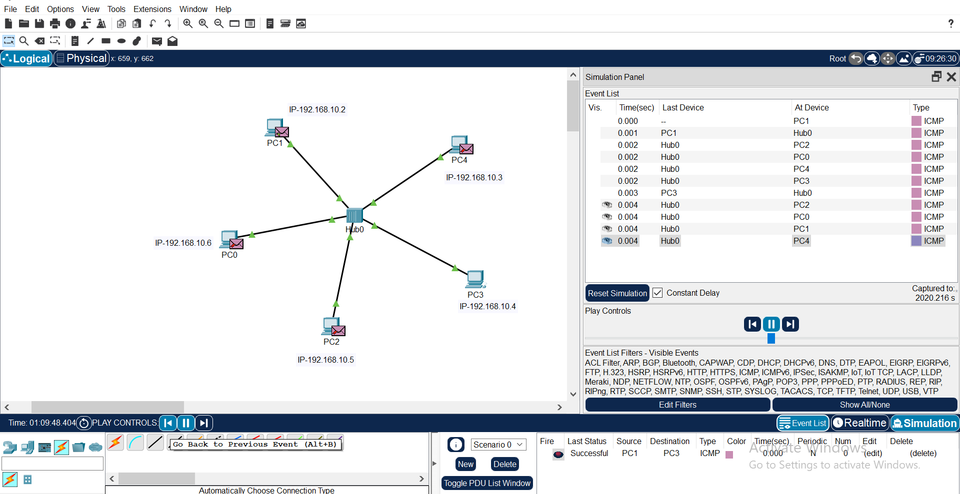
(b).Star Topology using Switch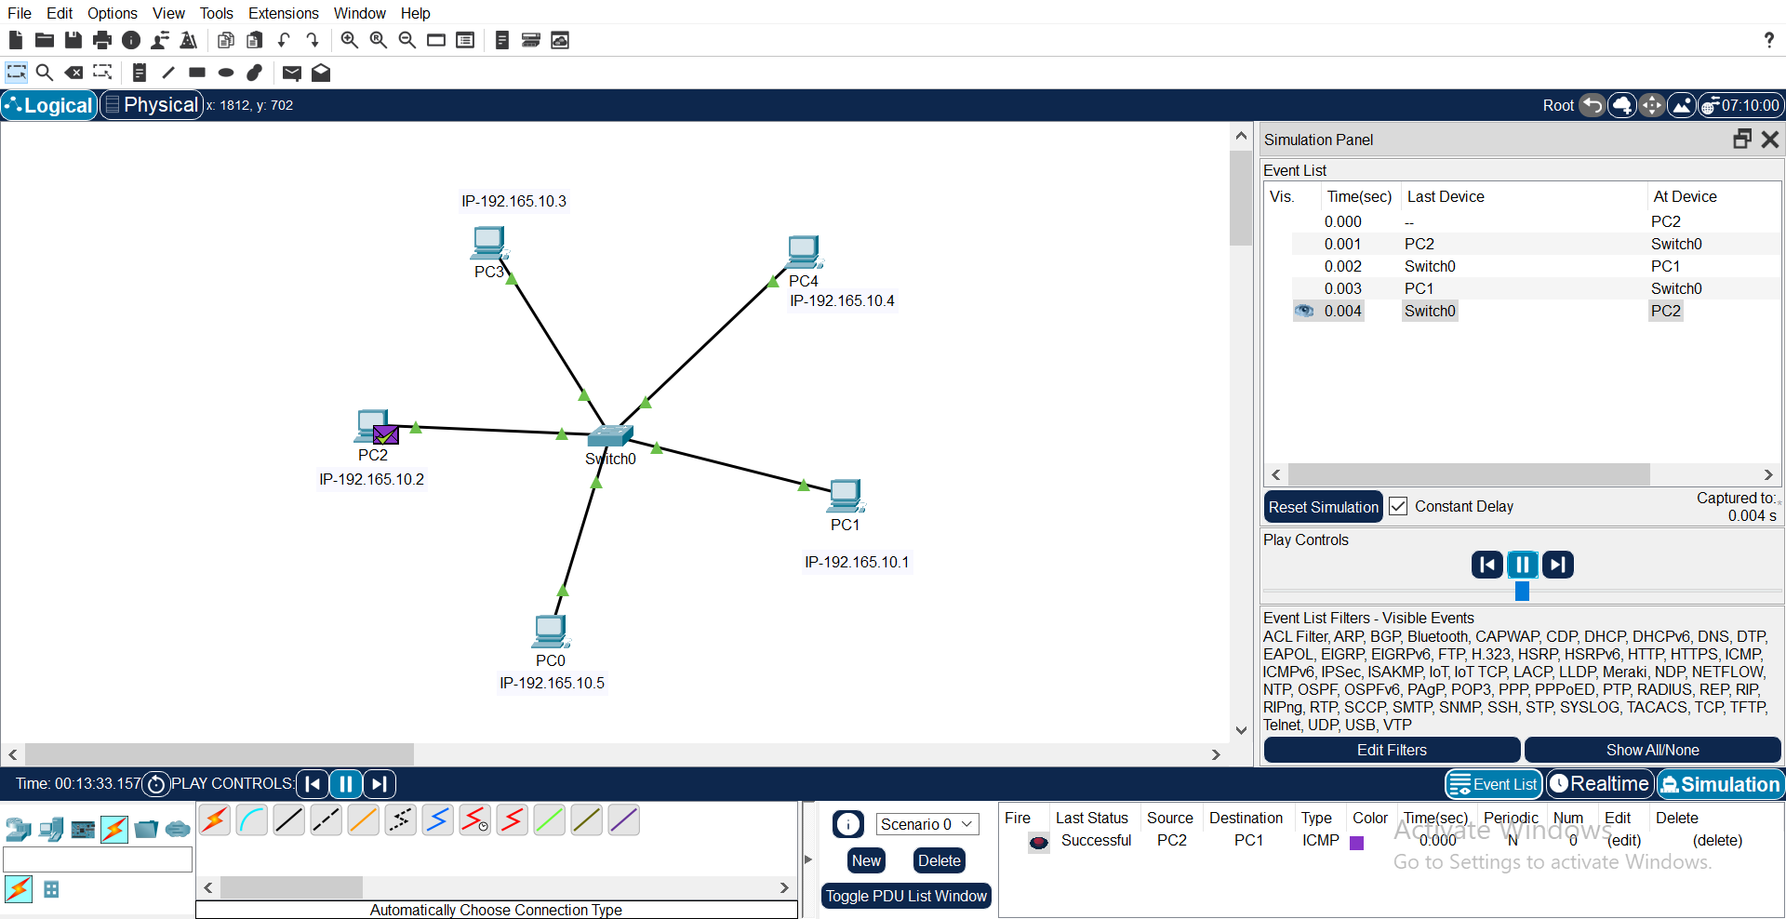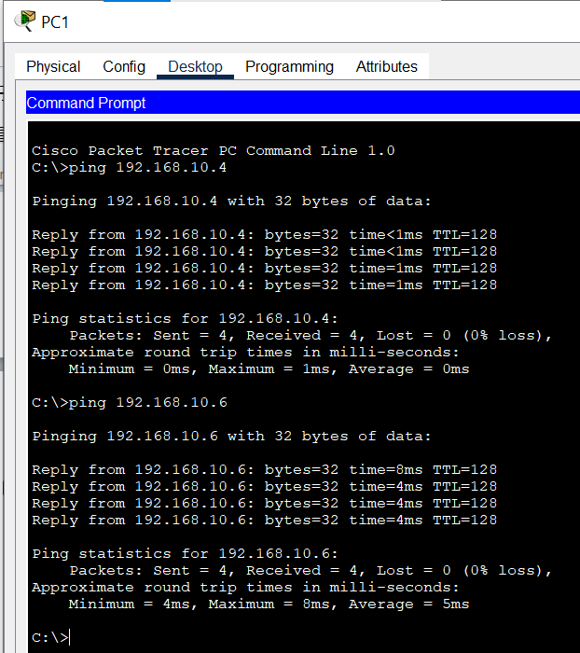Testing Network
Q.3:- To create BUS, RING,HYBRID and MESH TOPOLOGIES.
(a). BUS Topology
Steps:-
Step 1:- Open the Cisco Packet Tracer .
Step 2:- Click on End Devices that is on the left corner of Cisco Packet Tracer window.
Step 3:- Select 14 PCs and 7 switches and connect all the PCs to respective switch like PC0 and PC1 with Switch 01 with Copper Straight through and connect all the switches using copper cross over wire.
Step 4:- Configure the IP of each PCs.(PC0 => 10.1.1.1), (PC1 => 10.1.1.8), (PC2 => 10.1.1.9), (PC3 => 10.1.1.2), (PC4 => 10.1.1.3), (PC5 => 10.1.1.10), (PC6 => 10.1.1.11), (PC7 => 10.1.1.4), (PC8 => 10.1.1.5), (PC9 => 10.1.1.12), (PC10 => 10.1.1.13), (PC11 => 10.1.1.6), (PC12 => 10.1.1.7), (PC13 => 10.1.1.14).
Step 5:- Test the network using command prompt by pinging the destination IP address or selecting PDU and giving two PCs and simulating them.
(b). Ring Topology
Steps:-
Step 1:- Open the Cisco Packet Tracer .
Step 2:- Click on End Devices that is on the left corner of Cisco Packet Tracer window.
Step 3:- Select 4 PCs and 4 switches and connect all the Switches in a circle and connect all the PCs to respective switch like PC0 with Switch 01 with Copper Straight through and connect all the switches using copper cross over wire.
Step 4:-Configure the IP address of each PCs.(PC0=>192.165.10.1),(PC1=>192.165.10.2),(PC2=>192.165.10.4) and (PC3=>192.165.1
Step 5:- Test the network using command prompt by pinging the destination IP address or selecting PDU and giving two PCs and simulating them.
(c).Tree Topology
Steps:-
Step 1:- Open the Cisco Packet Tracer .
Step 2:- Click on End Devices that is on the left corner of Cisco Packet Tracer window.
Step 3:- Select 7 PCs and 7 switches and connect all the Switches in a tree like structure and connect all the PCs to respective switch like PC0 with Switch 01 with Copper Straight through and connect all the switches using copper cross over wire.
Step 4:-Configure IP address of each PCs. (PC0 => 10.1.1.6), (PC1 => 10.1.1.5), (PC2 => 10.1.1.1), (PC3 => 10.1.1.8), (PC4 => 10.1.1.7), (PC5 => 10.1.1.2), (PC6 => 10.1.1.3).
Step 5:- Test the network using command prompt by pinging the destination IP address or selecting PDU and giving two PCs and simulating them.

(d).Mesh Topology
Steps:-
Step 1:- Open the Cisco Packet Tracer .
Step 2:- Click on End Devices that is on the left corner of Cisco Packet Tracer window.
Step 3:- Select 4 PCs and 4 switches and connect all the Switches with each other so that every switch should be connected to every switch and connect all the PCs to respective switch like PC0 with Switch 01 with Copper Straight through and connect all the switches using copper cross over wire.
Step 4:- Configure IP address of each PCs.(PC0=>10.1.1.1),(PC1=>10.1.1.2),(PC2=>10.1.1.3) and (PC3=>10.1.1.4).
Step 5:- Test the network using command prompt by pinging the destination IP address or selecting PDU and giving two PCs and simulating them.
(e).Hybrid Topology
Steps:-
Launch Cisco Packet Tracer: Open the Cisco Packet Tracer application on your computer.
ii. Plan Your Hybrid Topology: Decide which types of network topologies you want to combine and how you want to interconnect them. For example, you might want to have a main Star topology with additional Bus or Ring topologies branching off from it.
iii. Create Main Topology: Start by creating your main topology. This could be a Star topology with a Switch at the center and multiple PCs connected to it.
iv. Add Additional Topologies: Once you have your main topology set up, add additional topologies as needed. For example, you could add a Bus topology by connecting a few PCs directly to each other using straight-through copper cables.
v. Interconnect Topologies: Use routers, switches, or even end devices to interconnect the different topologies. For instance, you could connect the main Star topology to the Bus or Ring topology using a router or a switch.
vi. Assign IP Addresses (Optional): If you want to configure IP addresses for the devices, double-click on each device to open its configuration window. Navigate to the "Desktop" tab and select "IP Configuration". Assign IP addresses to each device in the same subnet.
vii. Verify Connectivity: Open the command prompt or terminal on each device and use the ping command followed by the IP address of another device to verify connectivity. For example, on PC1, type ping [IP address of PC2] and press Enter. You should receive replies indicating successful communication.
viii. Observe Hybrid Topology Operation: Test the communication between devices in different parts of the network and observe how data flows through the various interconnected topologies.

Screenshots:-
(a). 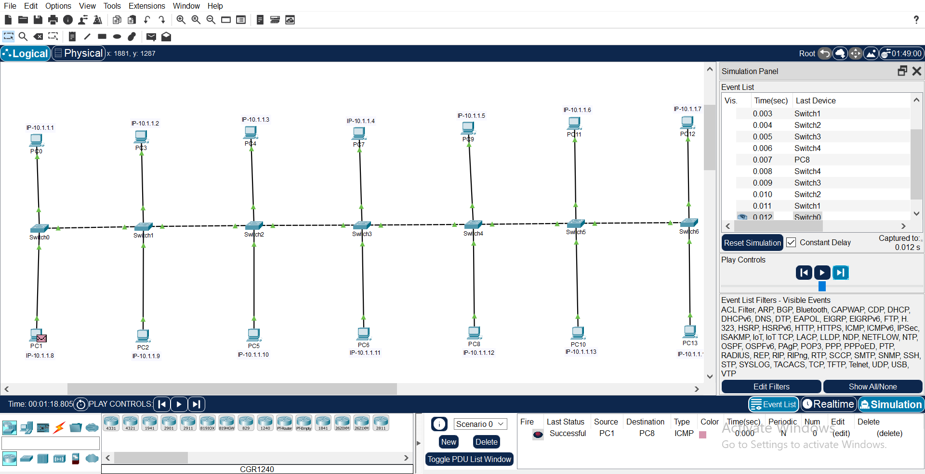
(b). 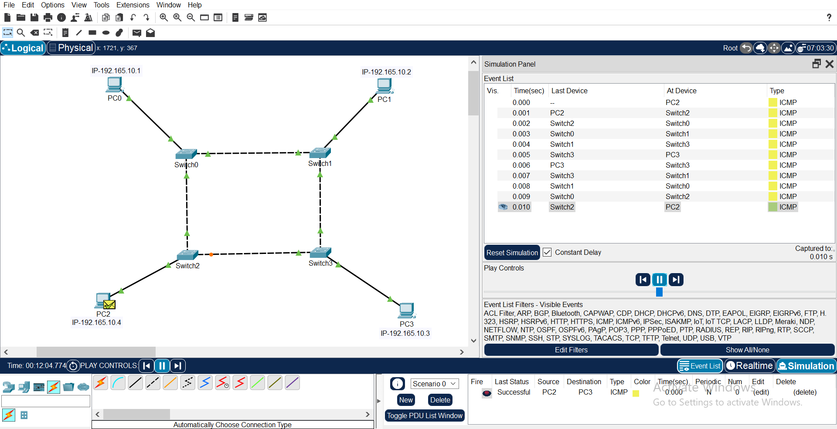
(c).
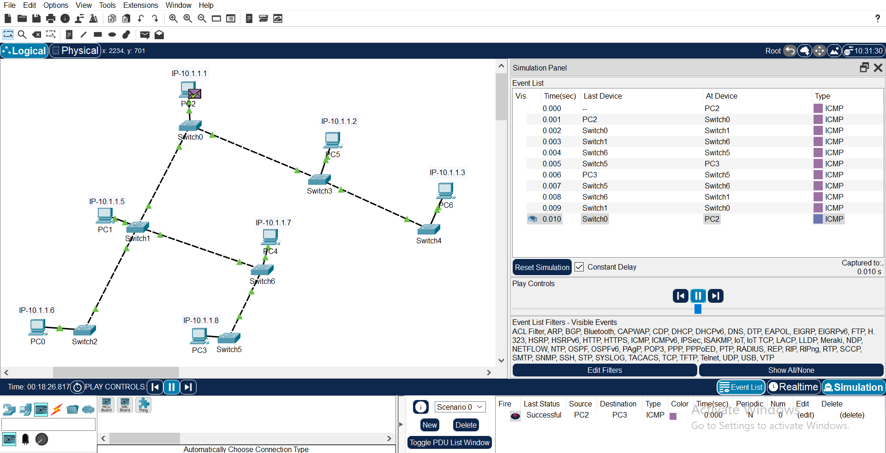
(d).
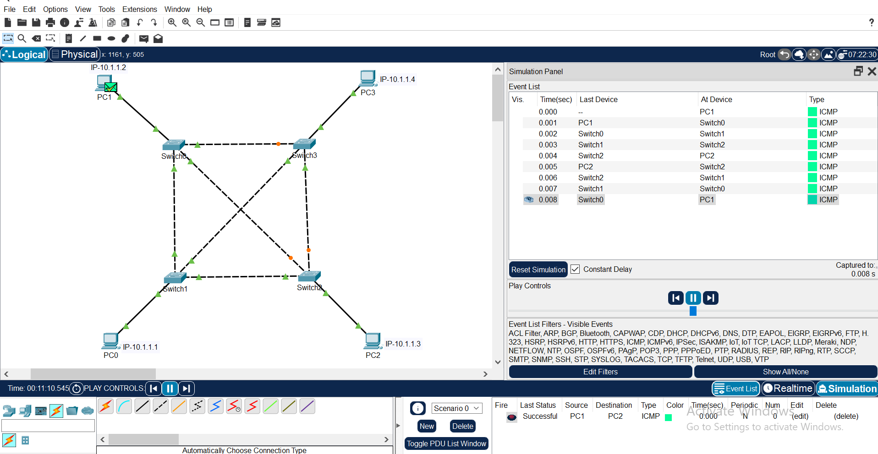
(e).
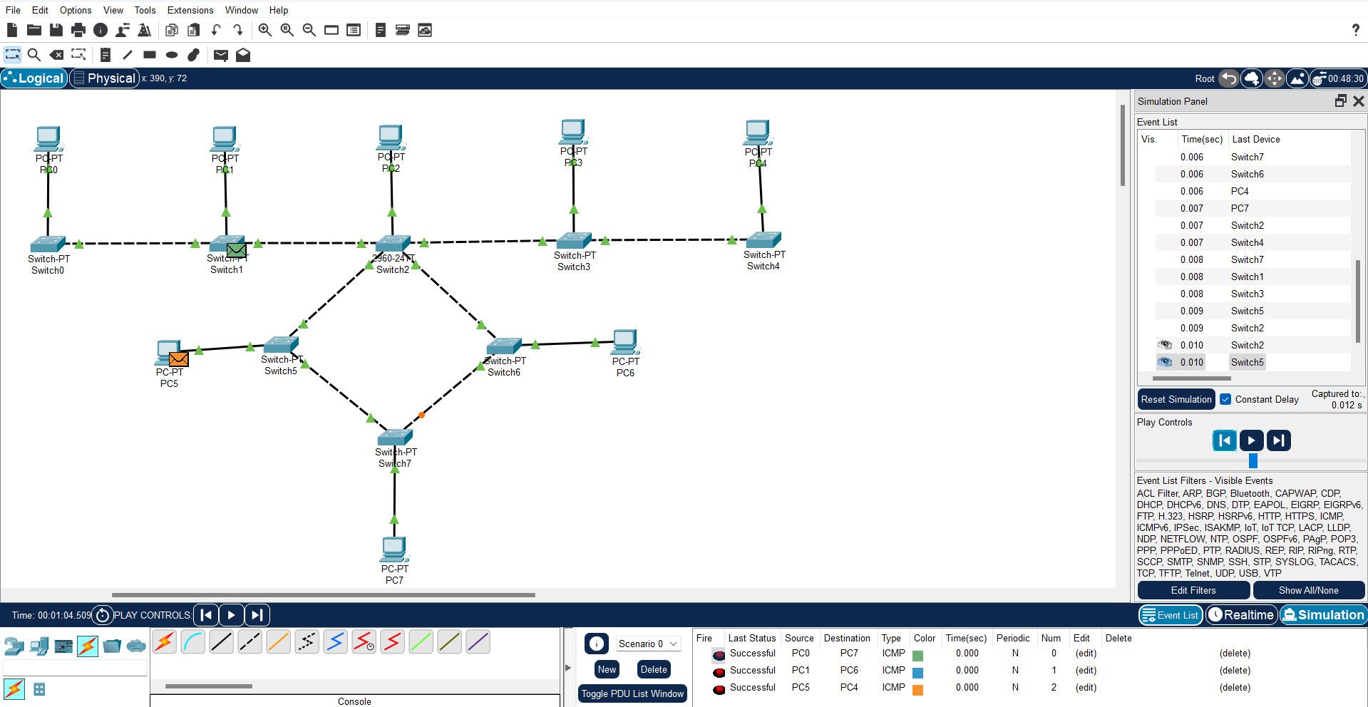

Q.4 :- Perform a intial switch configuration.
Screenshots:-
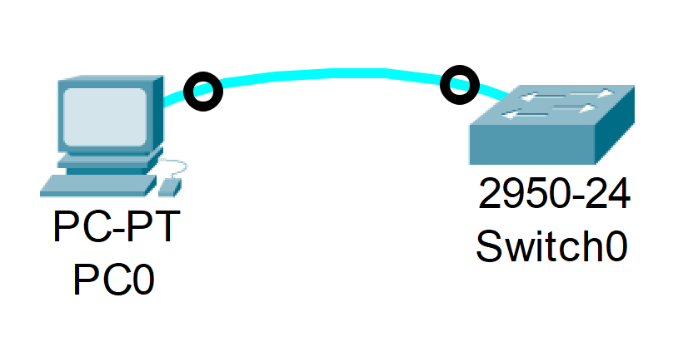
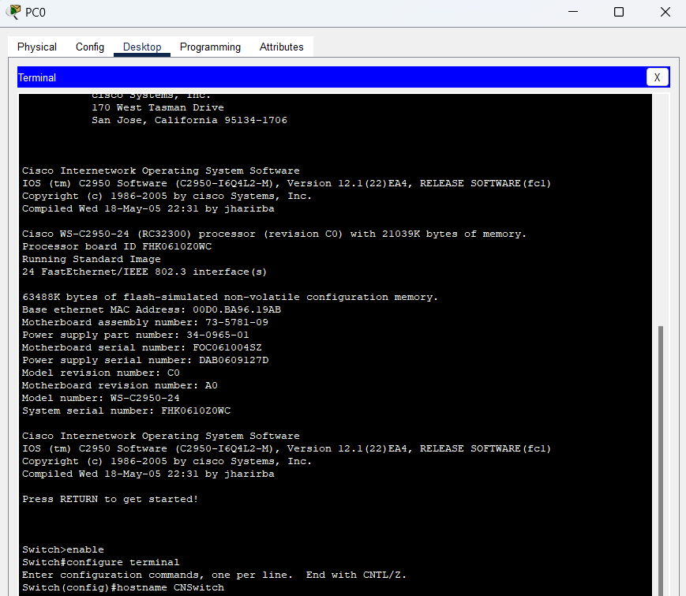
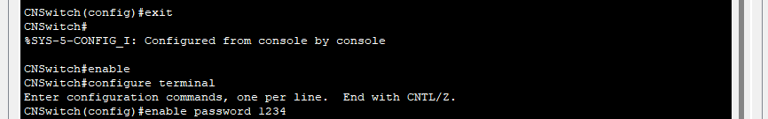
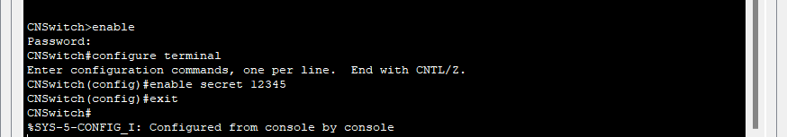
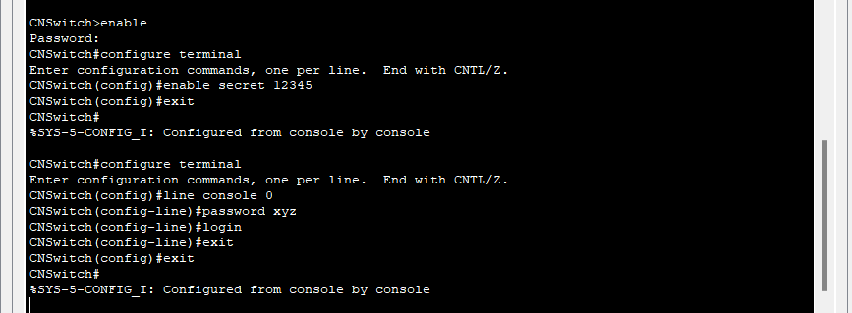
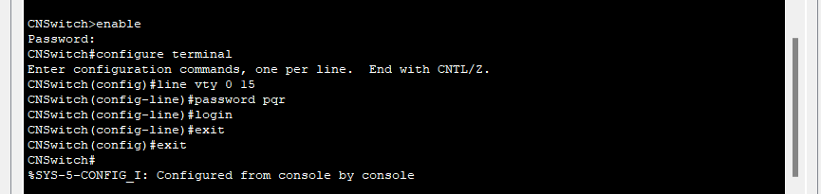
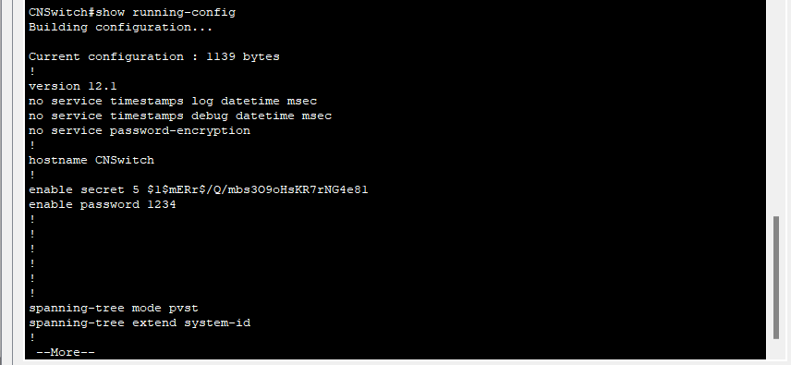
Q.5:-Perform the initial Router Configuration.
Screenshots:-
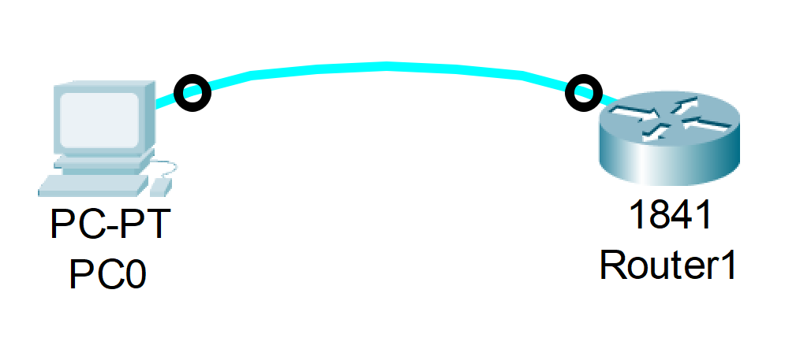
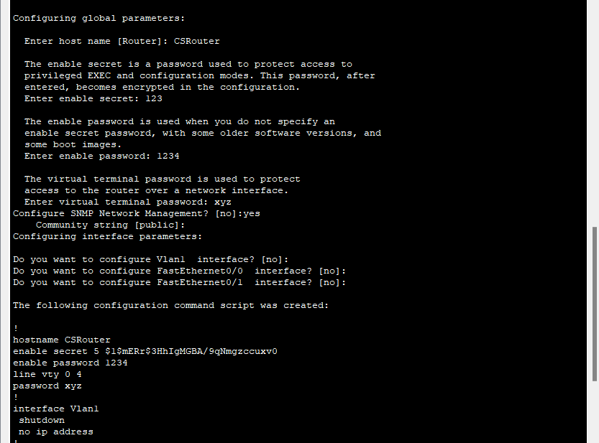
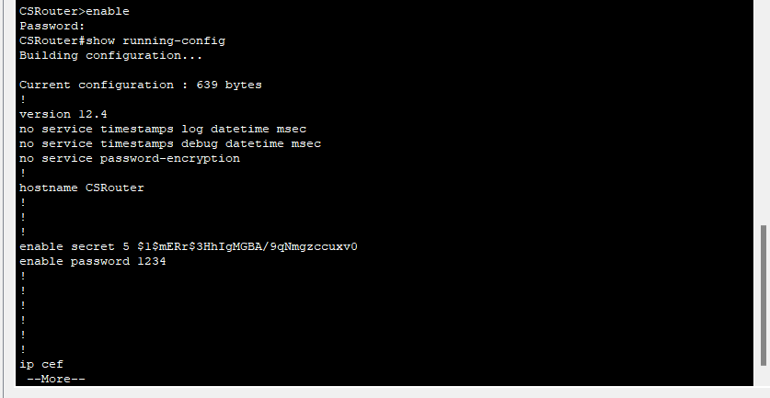
Q.6:-To implement Client Server Network.
Steps:-

- Launch Cisco Packet Tracer: Open the Cisco Packet Tracer application on your computer.
- Create Network Topology: Start a new project by selecting "Empty Physical Workspace". Then, drag and drop the necessary devices onto the workspace. You'll need at least one server device and one or more client devices.
- Select Server Device: Choose a device to act as the server. This could be a PC or a server device from the "End Devices" section. Drag and drop it onto the workspace.
- Select Client Devices: Choose one or more devices to act as clients. These could be PCs or laptops from the "End Devices" section. Drag and drop them onto the workspace.
- Connect Devices: Use appropriate cables to connect the client devices to the server device. For wired connections, use Ethernet cables. For wireless connections, configure the devices accordingly.
- Configure Server Services (Optional): Double-click on the server device to open its configuration window. If necessary, configure the server's operating system to provide the desired services. This could include setting up file sharing, web hosting, database services, etc.
- Assign IP Addresses (Optional): Double-click on each device to open its configuration window. Navigate to the "Desktop" tab and select "IP Configuration". Assign IP addresses to each device in the same subnet. This step is optional but can help in managing the network and ensuring proper communication.
- Verify Connectivity: Open the command prompt or terminal on each device and use the ping command followed by the IP address of another device to verify connectivity. For example, on a client device, type ping [IP address of the server] and press Enter. You should receive replies indicating successful communication.
- Access Server Resources: On the client devices, you can now access the resources or services provided by the server. This could include accessing shared files, websites hosted on the server, databases, etc.
- Test Communication: Perform various tasks on the client devices that require interaction with the server. This could involve accessing files, browsing websites, or querying databases.
- Monitor Network Traffic (Optional): You can use Packet Tracer's simulation mode to monitor network traffic and analyze how data flows between the client and server devices.

Screenshots:-
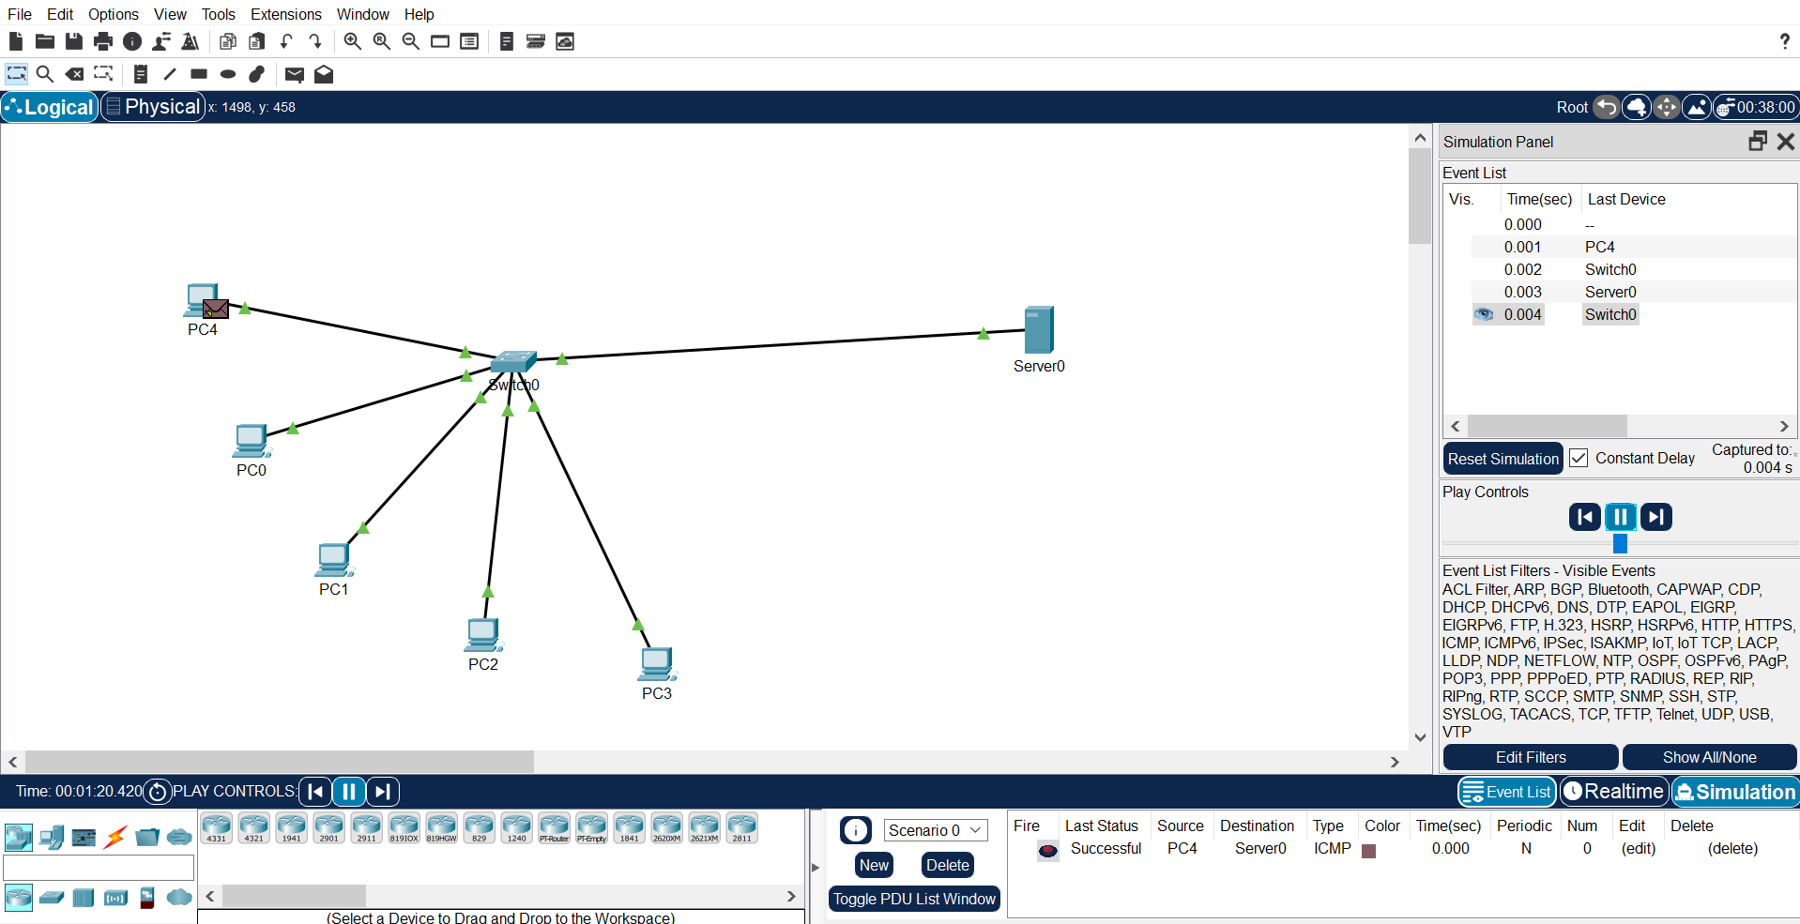
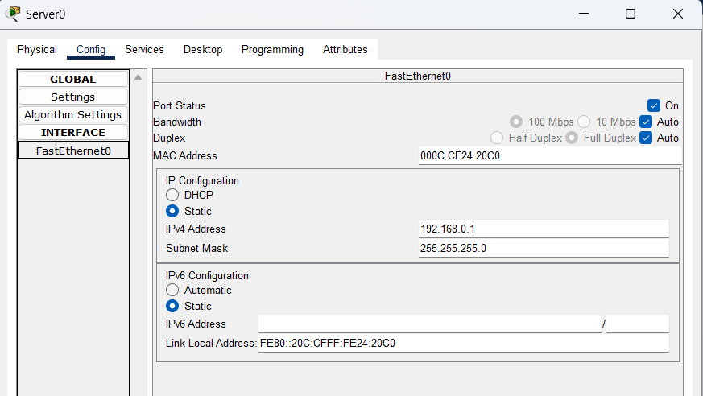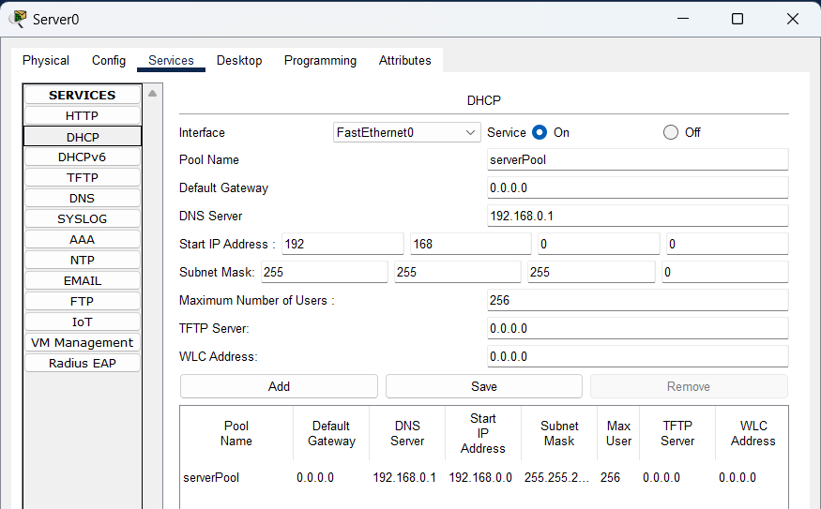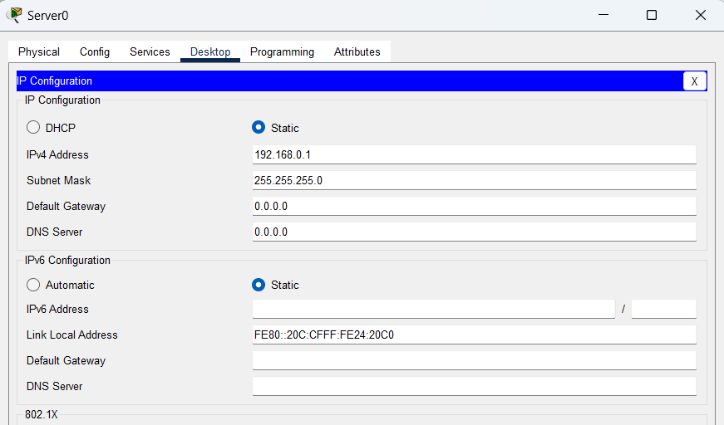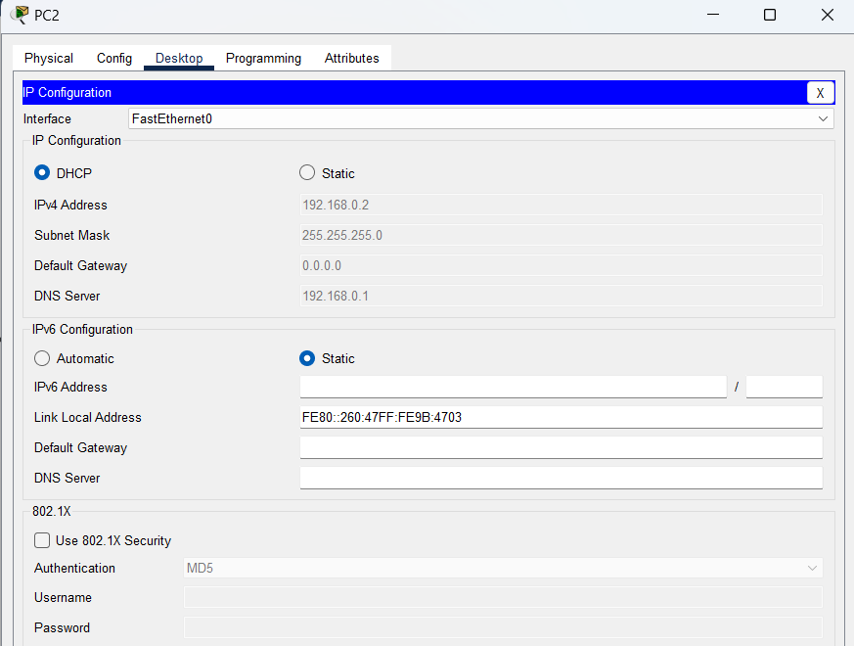
Q.7:-To implement connection of devices using router.
Steps:

- Launch Cisco Packet Tracer: Open the Cisco Packet Tracer application on your computer.
- Create Network Topology: Start a new project by selecting "Empty Physical Workspace". Then, drag and drop the devices you want to connect onto the workspace. You'll need at least two devices (e.g., PCs or switches) and a router.
- Add a Router: Drag and drop a router from the "Routers" section onto the workspace.
- Connect Devices to the Router: Use appropriate cables (usually straight-through copper cables) to connect the devices to the router. For example, connect PCs or switches to the router's Ethernet ports.
- Assign IP Addresses (Optional): Double-click on each device to open its configuration window. Navigate to the "Desktop" tab and select "IP Configuration". Assign IP addresses to each device in the same subnet. If you're using a router, assign IP addresses to its interfaces as well.
- Verify Connectivity: Open the command prompt or terminal on each device and use the ping command followed by the IP address of another device to verify connectivity. For example, from a PC connected to one interface of the router, ping a PC connected to another interface of the router.
- Test Communication: Once connectivity is verified, test communication between devices by exchanging data or accessing shared resources.
Screenshot:-
